PROJECT DOCUMENTATION

Orderonthego : Your on-demand food ordering

Technlogy Stack : React.js | Node.js | Express.js | MongoDB

Modules : User Management | Admin | Food Details | Cart | Order |
Authentication

Project Title : Orderonthego: Your on-demand food ordering

Team ID : LTVIP2026TMIDS24286
Team Size : 4

Team members and Roles :
Team Leader : Palli Deepthi Sai Sree ( Frontend Developer)
Team member : Polagani Lakshmi Venkata Sai Ram ( Frontend Support)
Team member : Sanaka Gowthami ( UI/UX Designer )
Team member : Shaik Farooq ( Full Stack Developer, Backend Developer )

Table of Contents

1 . Introduction
2 . Project Overview
3 . Architecture
4 . Setup Instructions
5 .Folder Structure
6 . Running the Application
7 . API Documentation
8 . Authentication
9 . User Interface
10 . Testing
11 . Screenshots / Demo
12 . Know Issues
13 . Future Enchacements
14 . Appendix A: UI Screenshots

Orderonthego: your on-demand food ordering

Full Stack MERN Project Documentation

1. Introduction

Project Title
orderonthego: your on-demand food ordering

About the Project
OrderOnTheGo is a full-stack web application developed using the MERN stack (MongoDB, Express.js, React.js, Node.js). It functions as an online food ordering platform where users can browse food items, view detailed descriptions, add items to their cart, and place orders easily.
The system is designed to simulate a real-world on-demand food delivery service. Users can register and login securely, explore various food categories, search for their favorite dishes, manage their cart, and track their orders.
The platform supports role-based functionality for different types of users:
• Customers can browse food items, add items to cart, place orders, and track order history.
• Admin can manage food items, categories, users, and monitor all orders through an admin dashboard.
The application ensures secure authentication, smooth API communication between frontend and backend, and a responsive user interface that works across desktop and mobile devices.

Objective
• To develop a responsive and scalable on-demand food ordering web application using the MERN stack.
• To implement secure authentication and authorization using JWT (JSON Web Token).
• To allow customers to browse food items, filter by category, and manage their cart efficiently.
• To enable users to place orders and maintain order history.
• To provide an admin panel to manage food items, users, and orders effectively.
• To design a user-friendly and interactive interface for a seamless food ordering experience.

2. Project Overview

Purpose
The purpose of OrderOnTheGo is to design and implement a fully functional, user-friendly, and responsive online food ordering platform. In today’s fast-paced digital world, customers prefer ordering food online due to convenience, speed, and accessibility. OrderOnTheGo fulfills this need by providing a centralized platform where food items are displayed with details such as name, description, price, category, and images.
The platform supports role-based access such as Customer and Admin. Each role has its own permitted actions and dashboard features. This structure reflects a real-world online food ordering workflow.

Goals
• Build a complete MERN stack application with frontend, backend, and database integration.
• Implement secure authentication and protected routes using JWT.
• Provide core food ordering features such as food browsing, cart management, and order placement.
• Allow customers to track their order history.
• Provide admin features to manage food items, users, and orders.
• Ensure responsive design for both desktop and mobile users.

Key Features / Modules
The OrderOnTheGo platform includes the following key modules:
• Authentication Module (Register / Login with secure JWT authentication)
• Food Browsing Module (View food items with images, categories, and prices)
• Search & Filter Module (Search foods by name or category)
• Food Details Module (View detailed description of selected item)
• Cart Module (Add to cart, update quantity, remove items)
• Order Module (Place order, view order history)
• Admin Dashboard (Manage food items, users, and orders)
• User Profile Module (View user information and order history)

3. Architecture
OrderOnTheGo follows a modern 3-tier MERN architecture:
• MongoDB (Database Layer)
• Express.js + Node.js (Backend/API Layer)
• React.js (Frontend/Presentation Layer)
This architecture ensures scalability, maintainability, and clear separation of concerns.

Front-end Architecture – React.js
The frontend is built using React.js, enabling dynamic and responsive user interfaces through reusable components and page-based routing.
• React Router DOM is used for navigation between pages (Home, Login, Register, Cart, Orders, Admin Dashboard).
• Conditional rendering is used to show features based on user authentication and role.
• Axios is used to communicate with backend REST APIs.
• The UI is styled using CSS and Bootstrap to provide a clean and responsive design.
• Components are modularized (Navbar, FoodCard, CartPage, LoginPage, etc.) for better maintainability.

Back-end Architecture – Node.js & Express.js
The backend is developed using Node.js and Express.js. It exposes REST APIs for authentication, food management, cart management, and order processing.
• Routes are modularized by feature (auth, foods, users, cart, orders).
• Controllers contain business logic for each API endpoint.
• Middleware verifies JWT tokens and protects routes.
• Passwords are securely hashed before storing in the database.
• Environment variables are managed using dotenv for security.

Database Architecture – MongoDB
MongoDB is used as the NoSQL database for storing user data, food items, cart details, and order information. MongoDB provides flexibility and scalability for modern web applications.
• Users collection stores user credentials and role information.
• Foods collection stores food item details such as name, price, category, and image.
• Orders collection stores order details, total amount, and status.

• Cart collection stores user-specific cart items.
The database structure ensures efficient data retrieval and relationship management between users and orders.

4. Setup Instructions

Prerequisites
 | Purpose | Recommended Version
  Tool
Node.js | JavaScript runtime environment | v18+
Npm | Node packadge manager | v9+
MongoDB(Local) | Database for storing data | Any stable version
Git | Version control | Latest
VS code | Code editor | Optional
Postman/Thunder Client | API testing | Optional

Installation Guide

Step 1: Clone the Project Repository
git clone https://github.com/your-username/orderonthego.git
cd orderonthego

Step 2: Install Dependencies
Install frontend packages:
cd frontend
npm install
Install backend packages:
cd ../backend
npm install

Step 3: Set Up Environment Variables
Inside the /backend folder, create a .env file and add:
MONGO_URI=mongodb://127.0.0.1:27017/orderonthego
JWT_SECRET=your_secret_key
PORT=5000

Step 4: Run the Application
Start backend server:
cd backend

npm start
Start frontend React app:
cd ../frontend
npm start

Once started:
• Frontend runs on: http://localhost:3000
• Backend runs on: http://localhost:5000

5. Folder Structure

Frontend Folder Structure (React)
Folder/File | Purpose
/frontend | Root folder for React app
/public | Static assets
/src/cpmponents | Reusable  UI components(Navbar,FoodCard,etc.)
/src/pages | Pages like Home, Login, Register, Cart, Orders
App.js | Central router
index.js | React entry point
Package.json | Frontend dependencies

Backend Folder Structure (Node.js + Express)
Folder/File | Purpose
/backend | Root folder for backend
/models | Mongoose schemas (User,Food, Order,Cart)
/routes | Express routes
/controller | Business logic
/middleware | JWT authentication middleware
Server.js | Backend entry point
.env | Environment variables
Package.json | Backend dependencies

6. Running the Application
Start frontend:
cd frontend
npm start

Start backend:
cd backend

npm start

Expected URLs:
• Frontend UI: http://localhost:3000
• Backend API: http://localhost:5000/api

7. API Documentation
The OrderOnTheGo backend exposes REST-style APIs. All routes return JSON format.
Authentication Routes

Method | Endpoint | Description
POST | /api/users/register | Register new user
POST | /api/users/login | Login user

Food Routes

Method | Endpoint | Description | Access
GET | /api/foods | Fetch all food items | Public
GET | /api/foods/:id | Fetch single food | Public
POST | /api/foods | Add new food | Admin
PUT | /api/foods/:id | Update food | Admin
DELETE | /api/foods/:id | Delete food | Admin

Cart Routes

Method | Endpoint | Description
POST | /api/cart | Add item to cart
GET | /api/cart | Get cart items
DELETE | /api/cart/:id | Remove cart item

Order Routes

Method | Endpoint | Description | Access
POST | /api/orders | Place an order | User
GET | /api/orders/myorders | Get user order | User
GET | /api/orders | Get all orders | Admin
PUT | /api/orders/:id | Update order status | Admin

8. Authentication
OrderOnTheGo uses secure JWT-based authentication with role-based access (User / Admin).
Authentication Flow

Step | Action | What Happens
1 | Register | User details stored in MongoDB after password hashing (bcrypt)
2 | Login | Server validates credentials and returns JWT token
3 | Protected Requests | Frontend sends token in header: Authorization: Bearer <token>

JWT Token Details

Field | Purpose
userId | MongoDB ID of the logged-in user
email | Email address of the user
role | user / admin
iat | Token issued time
exp | Token expiry time

9. User Interface
The OrderOnTheGo user interface is designed for simplicity, responsiveness, and smooth navigation. The UI supports two main roles: User and Admin.

UI Screens / Pages
• Home Page: Landing page displaying food items and categories.
• Login Page: User login form with email and password.
• Signup Page: User registration form.
• Food Listing Page: Displays all available food items as cards.
• Food Details Page: Shows detailed information about selected food item.
• Cart Page: Displays selected food items with quantity and total price.
• Orders Page: Shows logged-in user's order history.
• Admin Dashboard: Manage food items, users, and orders.
• Admin Food Management Page: Add, update, delete food items.
• Admin Orders Page: View and update order status.

10. Testing
Manual testing was performed to ensure proper functionality, stability, and role-based access control.

Front-end Testing
• Validated Login and Signup forms.
• Verified correct navigation after login.
• Checked food listing and food details rendering.
• Verified cart operations (add, remove, update quantity).
• Tested order placement functionality.
• Verified responsive layout using browser developer tools.

Backend Testing
• Tested Register and Login API endpoints.
• Verified JWT-protected routes with valid and invalid tokens.
• Tested CRUD operations for food items (Admin access).
• Tested cart APIs for adding and removing items.
• Tested order placement and order retrieval APIs.
• Tested admin-only routes for managing foods and orders.

11. Screenshots / Demo
The following screenshots demonstrate the key pages and modules of the OrderOnTheGo platform.
Screenshots include:
• Home Page
• Login Page
• Signup Page
• Food Listing Page
• Cart Page
• Orders Page
• Admin Dashboard
• Admin Food Management
• Admin Orders Page

12. Known Issues
• No online payment gateway integration (orders are placed without payment processing).
• Limited search and filtering options (basic food listing only).
• No pagination (all food items load at once).
• No automated testing framework (manual testing only).
• No email verification during registration.

13. Future Enhancements
• Integrate online payment gateway (Razorpay / Stripe).
• Add advanced search and filtering (category, price range).
• Implement pagination or infinite scroll for better performance.
• Add order tracking with real-time status updates.
• Add email verification and forgot password functionality.
• Deploy frontend and backend to cloud platforms (Vercel/Netlify + Render/Railway).
• Improve UI design with animations and better UX.
14 . Appendix A: UI Screenshots
The screenshots are captured from the running application on localhost and demonstrate the working system and role-based dashboards.
Home Page ( Landing Screen ):
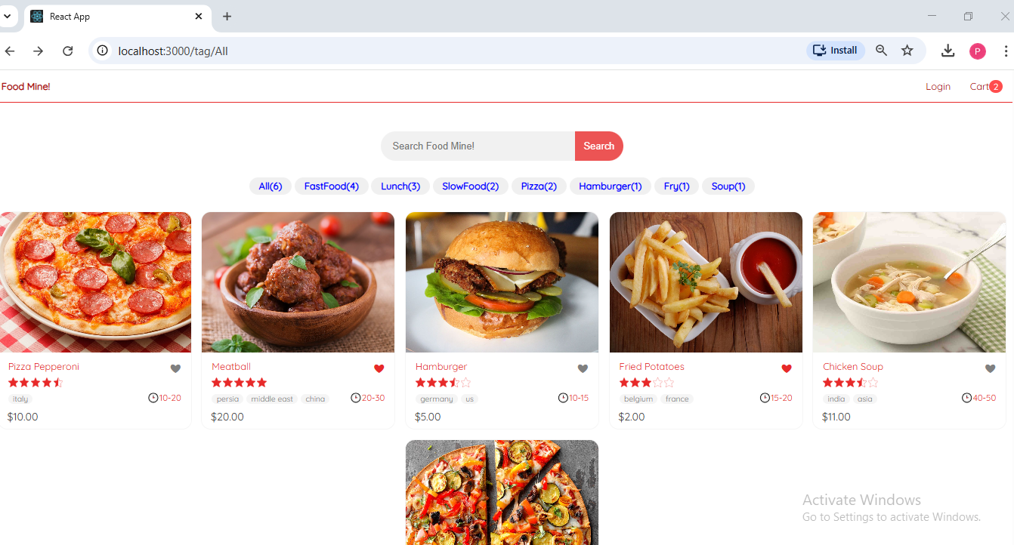

Registration Page:

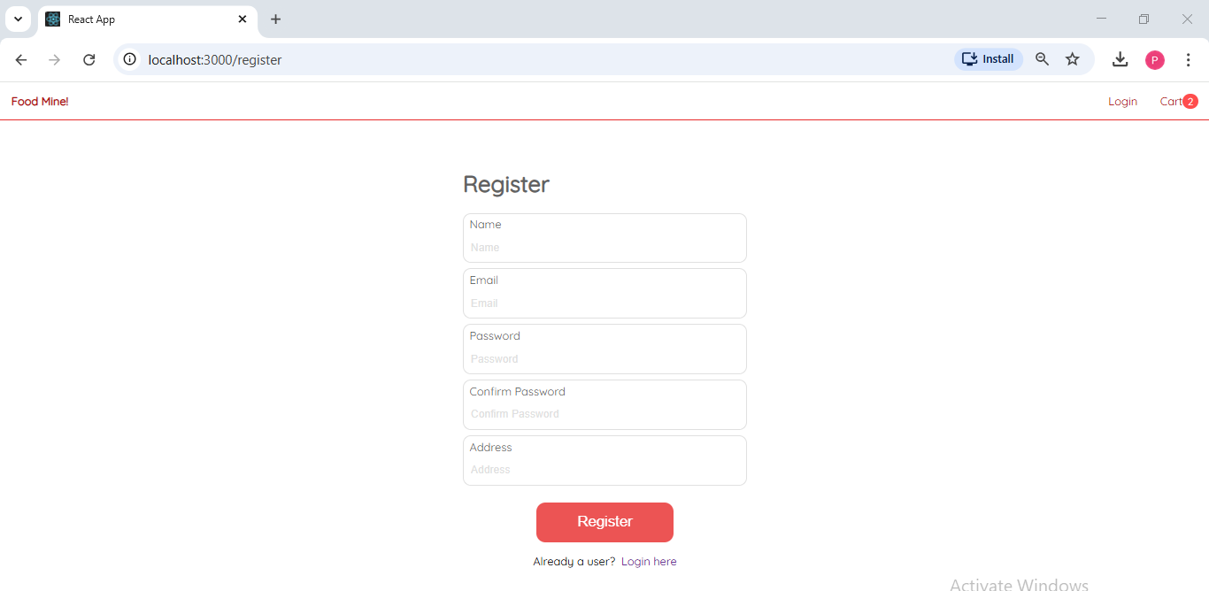
Login Page:

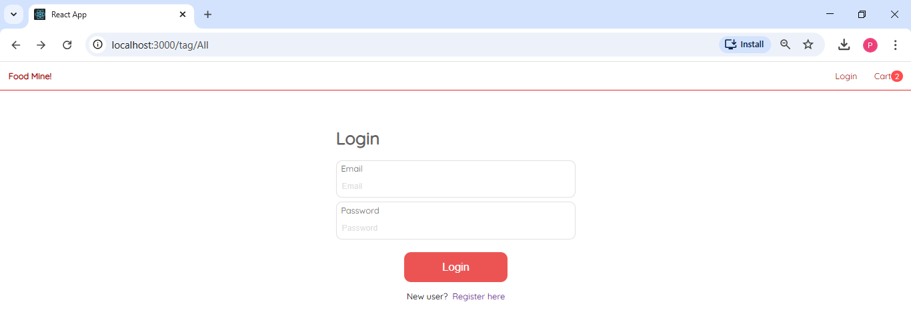

Cart Page :

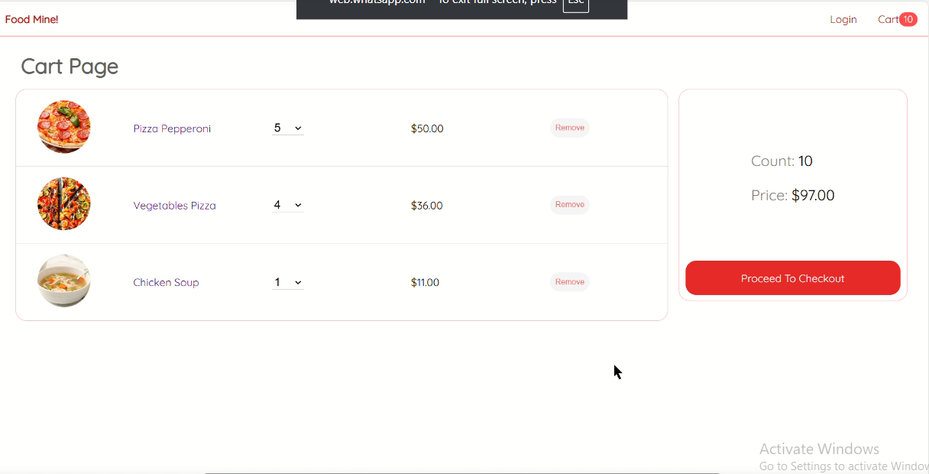

Search page :

